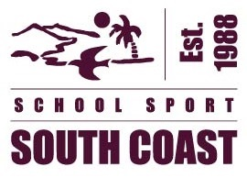
2025 SOUTH COAST REGIONAL OFFICIALS APPLICATION FORM
Part B – Principals Approval Form
The 2025 South Coast Regional Officials application form will not be processed unless South Coast School Sport Office receives the following Principal’s Approval Form
PRINCIPAL’S APPROVAL
Applicants Name
I agree to release the above mentioned teacher to attend the:
- Regional Trial and State Championships (Coach / Managers / Trainer Positions )

NB. State Championship dates listed are playing days and do not include travel days.
AND / OR
- Regional Trial only (Convenor positions )

NB. An Inservice will be facilitated Tuesday 3rd November 2024 approx. 1:00pm 4:00pm TBC. New officials will also be required for an after school induction in the new year.
- Approved □ Not Approved
Principal’s signature |  | Date
Comments

Applicants Preferences
Sport and team | Regional trial date | State Championship dates

APPLICANT’S DECLARATION
- I undertake to fulfil my responsibilities as a South Coast Regional Official as outlined in the relevant South Coast Regional Officials Handbook and school sport officials Codes of Conducts (South Coast and Queensland School Sport)
- If approved by my Principal, I will complete all my paperwork within my role by the timelines provided.

Applicant’s Name
Applicant’s signature |  | Date

Please return this Principal Approval Form by email to: Brendan.Jones@qed.qld.gov.au

