GC AQUATICS: South Coast Swim Trials TUESDAY 8 March 2022
Barrier
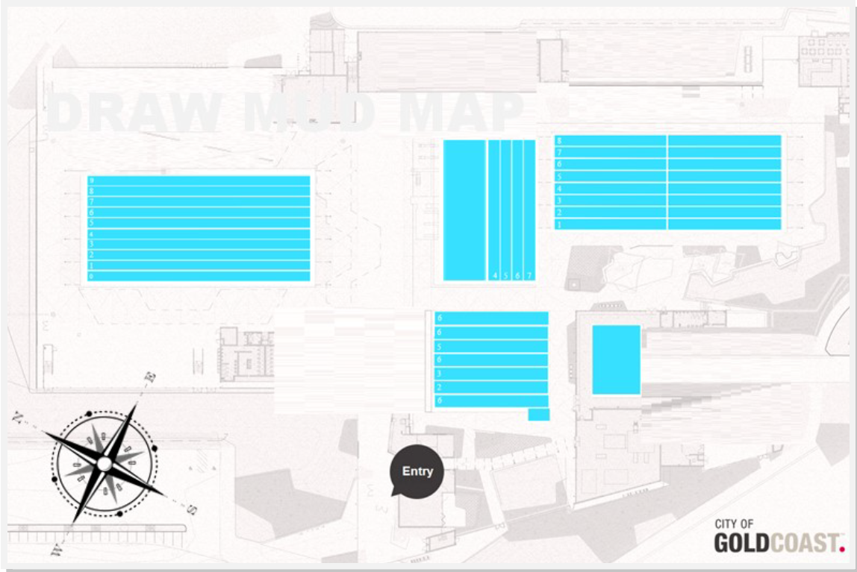
Sign displaying South Coast event left and General Public right
2 Tables set up inside gate – programs

Table
Table

SEATING UPSTAIRS WESTERN GRANDSTAND
Parent/Spectator
NO PARENTS/SPECTATORS PERMITTED ON
POOL DECK
No swimmers permitted in training pool.

Warm up lanes in the Dive pool only
Table

SEATING UPSTAIRS EASTERN GRANDSTAND
Parent/Spectator
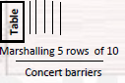
10 Tables – Downstairs
150 Chairs – Downstairs
6 Tables - in room upstairs
10 Chairs in room upstairs

Up Stairs
- Bollards for pathway from stairs to Team room
- 6 Tables in each room
- Approx. 10 chairs
Table
Table

- 2 x lifeguard
- Will use 1st aid room for duration of event
- PA System required
- Preferred change rooms are located under west side grandstand
- Results upstairs open space by meeting room—3 x whiteboards required
20 Chairs TWO per lane
10 Chairs One per lane
10 Chairs ONE per lane
First Aid
Starter tent

Starter tent
Starter tent

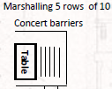
Glass room designated for Gold Coast Swimming officials only.
Scoreboard

